Fife teenager’s first book has a real festive feel
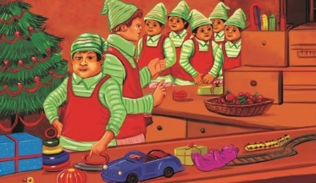
Christmas has come early for a young Fife writer who is about to have her first book published.
Joanna Kerr’s debut children’s story – a festive tale called I Can Do It Myself! – is being released by Cambridge-based publisher Pegasus Elliot Mackenzie on 30 June.
The teenager’s new book is set in Santa’s workshop in the run-up to Christmas and Erwin the strong-willed elf is super excited as the big day draws ever closer.
It follows Erwin’s adventures as he starts his dream job … following in the footsteps of his famous grandfather, Eric, who had been Santa’s trusty head elf.
Joanna, from Aberdour, came up with the idea at the start of the first Lockdown in 2020: “Erwin’s catch phrase – ‘I can do it myself’ – is one I used myself when I was younger … or, so my parents tell me!
“I came up with the initial idea – and then the whole thing quickly grew arms and legs … and a pointy hat. Hence Erwin the Elf was born.”
Eighteen-year-old Joanna, who starts a multimedia journalism degree at Glasgow Caledonian University in September, has enjoyed writing stories for as long as she can remember.
Says Joanna: “I think that I have a good sense of what appeals to children as I often read them bedtime stories when I was babysitting in the village.
“I wanted to write something that captured the excitement of Christmas as it is by far my favourite time of year. This year the build-up will be starting even earlier than usual!”
I Can Do It Myself! can be purchased via the Pegasus website: https://bit.ly/3byOqui. It is also hoped that local bookshops will stock it too.
