Sixties’ snaps by photo pioneer shed light on city’s past
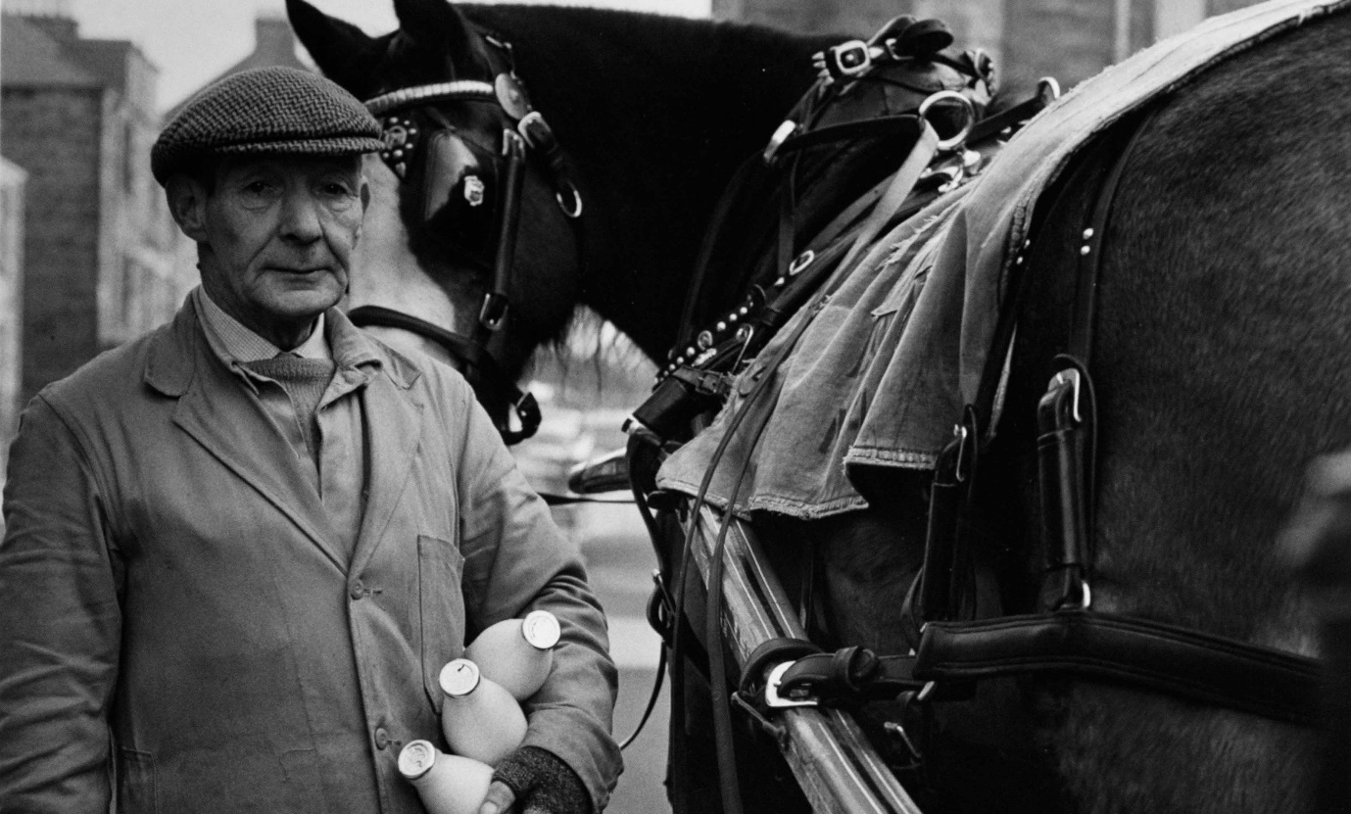
Captivating images taken in the 1960s by an influential photographer feature in an exhibition marking Dunfermline’s newly acquired city status.
Some 47 black and white pictures taken by Joseph McKenzie – dubbed ‘the Father of Modern Scottish Photography’ – have gone on show at Dunfermline Carnegie Library & Galleries.
If the past is a foreign country, then these photographs reveal a place just beyond the horizon, somehow out of reach and strange to us now.
Dunfermline and Its People was first shown in nearby Pittencrieff House Museum in 1968, McKenzie’s work having been commissioned by the Carnegie Heritage Trust.
Seen 54 years later, its content is a revelation –the horse-drawn milk cart and the lorry carrying ‘Blazo, four stick firelighters’ seeming even more anachronistic now than they must have been then.
All of the images were taken during 1967 and 1968, which was an eventful time for the former Royal Burgh.
In 1968, Dunfermline Athletic returned from Hampden Park with the Scottish Cup and an upcoming folk singer, Barbara Dickson, took the plunge to become a professional musician.
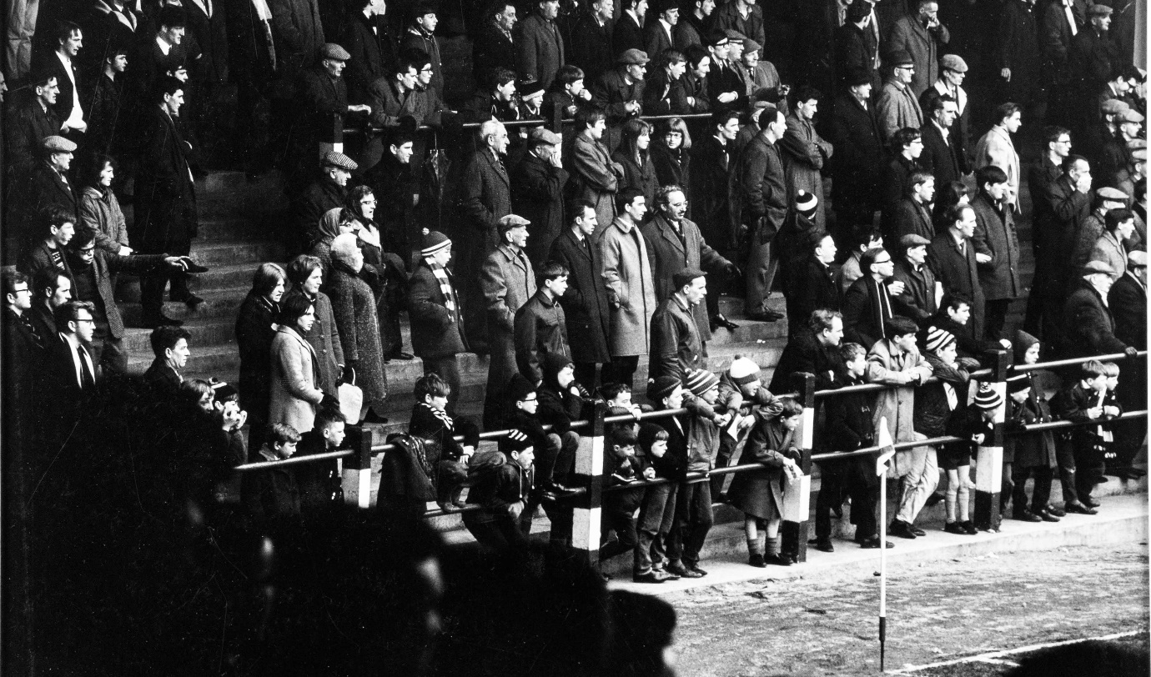
And the last passenger train departed Dunfermline Upper station – an indication that car ownership across Scotland was on the rise.
The 100-year-old Castleblair Works, built to weave linen before becoming a silk mill, closed in 1967 – a sign of the town’s move away from textiles production.
To the south of Dunfermline, an estimated 1000 families were settling into Pitcorthie housing estate as the town expanded, following the opening of the Forth Road Bridge.
Joseph McKenzie, who died in 2015 aged 86, became a prolific photographer through the 1960s, documenting Scotland as it underwent momentous change.
His work is held in the collections of the National Portrait Gallery of Scotland, the Victoria and Albert Museum and the McManus Art Gallery and Museum in Dundee.
McKenzie's son, Frank, recalls his father’s philosophy: “Show dad a car, and he would lift the bonnet and look underneath ... root around to see what made things tick and where the problems lay. It was the same with his photography.”
McKenzie studied contrasting aspects of Dunfermline society: from local councillors convening at the City Chambers to an assembly of rough sleepers, a stone’s throw away, beneath Glen Bridge; from smart schoolboys in their blazers to runny-nosed bairns, straight out of a Joan Eardley street scene.
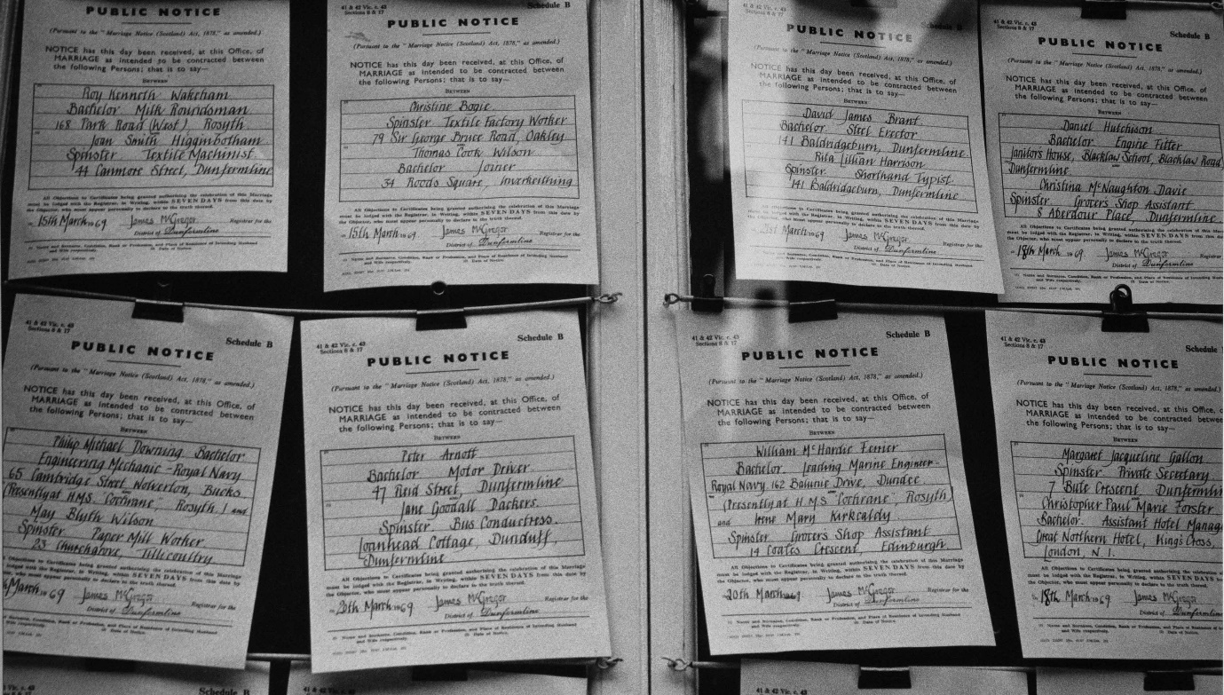
Throughout the exhibition are snapshots of the town’s social fabric: marriage banns published at the Registry Office inform us that a Rosyth engineering mechanic is due to be married to a paper mill worker; a motor driver to a bus conductress; and a soils and materials engineer to a sweet packer.
It is the tail end of full employment across the social spectrum though, ominously, McKenzie’s landscapes show us a deserted church, transformed into a garage that now lies abandoned too.
Elsewhere, washing lines contrast with chimneys and a gasometer and a stream of men clocks off at the Royal Naval Dockyard, but already the clock is running down – winds of change are blowing through the Auld Grey Toun.
Alice Pearson, a curator with the cultural charity OnFife, which runs the exhibition venue, says: “Joseph McKenzie really brings the city to life – its history, its location, its hustle and bustle, as well as the friendliness of its people."
“He gave us a remarkable portrait of a place in the midst of momentous change, providing glimpses of a world that has all but vanished. It is fitting that his legacy can be enjoyed by people once again as Dunfermline begins a new chapter in its illustrious story.”
Dunfermline and Its People runs from 19 November to 26 February 2023. Admission is free.
Versions of this story have appeared in The Times, The Scotsman, The Herald, Daily Express, Metro, Daily Record, Sunday Post, the Dunfermline Press and BBC online. Images are reproduced by kind permission of the artist's estate.
