Fab floor from Beatle home poses puzzle for museum curators
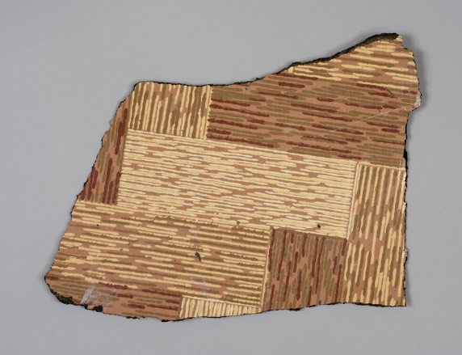
It may look a little drab but it is, in fact, something rather fab – a piece of the linoleum that furnished Paul McCartney’s childhood home.
Now museum curators in Fife, keen to establish where it was made, want to know if there’s a long and winding road back to Kirkcaldy.
The quest to find its source is part of a new venture that celebrates the Fife town’s remarkable industrial past, which saw it become a world leader in linoleum production.
Staff at Kirkcaldy Galleries will sift through pattern books from the 1950s to find a match for the former Beatle’s floor covering, which is still in the hall at 20 Forthlin Road, Liverpool.
If a match is found, curators will try to trace workers who produced the congoleum – a felt-backed budget version of linoleum – that was bought by Liverpool Corporation.
The quest Is one strand of a £115,000 project, backed by the Esmée Fairbairn Collections Fund, that seeks to engage people with the Galleries’ globally-renowned linoleum collection. The project starts later this year.
Kirkcaldy Galleries was donated the fab floor by the National Trust in 1997 – two years after it acquired the property where Paul McCartney lived from 1955 to 1964.
The sample, which measures 24cm by 9cm, has previously been displayed in Kirkcaldy but is currently in storage. Curators hope to put it back on show later this year.
Domestic Beatle-based memorabilia is highly prized. The original front door from 20 Forthlin Road– removed before the Trust acquired the property –reportedly sold for £5000 in 2013.
A pair of curtains from John and Cynthia Lennon’s Surrey mansion went up for auction at Sotheby’s last year with a list price of £3,000-£5,000.
Linoleum, and its many variants, has been dubbed the most ubiquitous and democratic of floor coverings, bought by customers across the social spectrum. The Galleries’ collection includes photographs, pattern books, catalogues, samples and workers’ tools.
Products made in Kirkcaldy – and the Fife villages of Falkland and Newburgh – floored millions of homes, offices and public buildings at home and abroad. At its peak, in 1914, the industry employed one in 10 of Kirkcaldy's population.
By the time the Beatles made their only concert appearance in the town – with two shows at the Carlton Theatre in 1963 – just one factory remained. It is still in production today and operated by Forbo.
Gavin Grant, Collections Team Leader with the cultural charity OnFife, which runs the Galleries, said “The McCartney’s floor covering is one of 6,000 objects in our internationally significant linoleum collection and we’d love to know if it was made in Fife.
“This new project will help us to promote the collection more widely and to conserve a vast range of artefacts that tell a quite remarkable story, which touched so many lives.”
The Esmée Fairbairn Collections Fund is run by the Museums Association, funding projects that develop collections to achieve social impact. Since its launch in 2011, it has awarded 101 projects with grants totalling £8.4 million.
Versions of this story have appeared in The Times, Daily Mail, Daily Star, Daily Record, The Scotsman and The Herald.
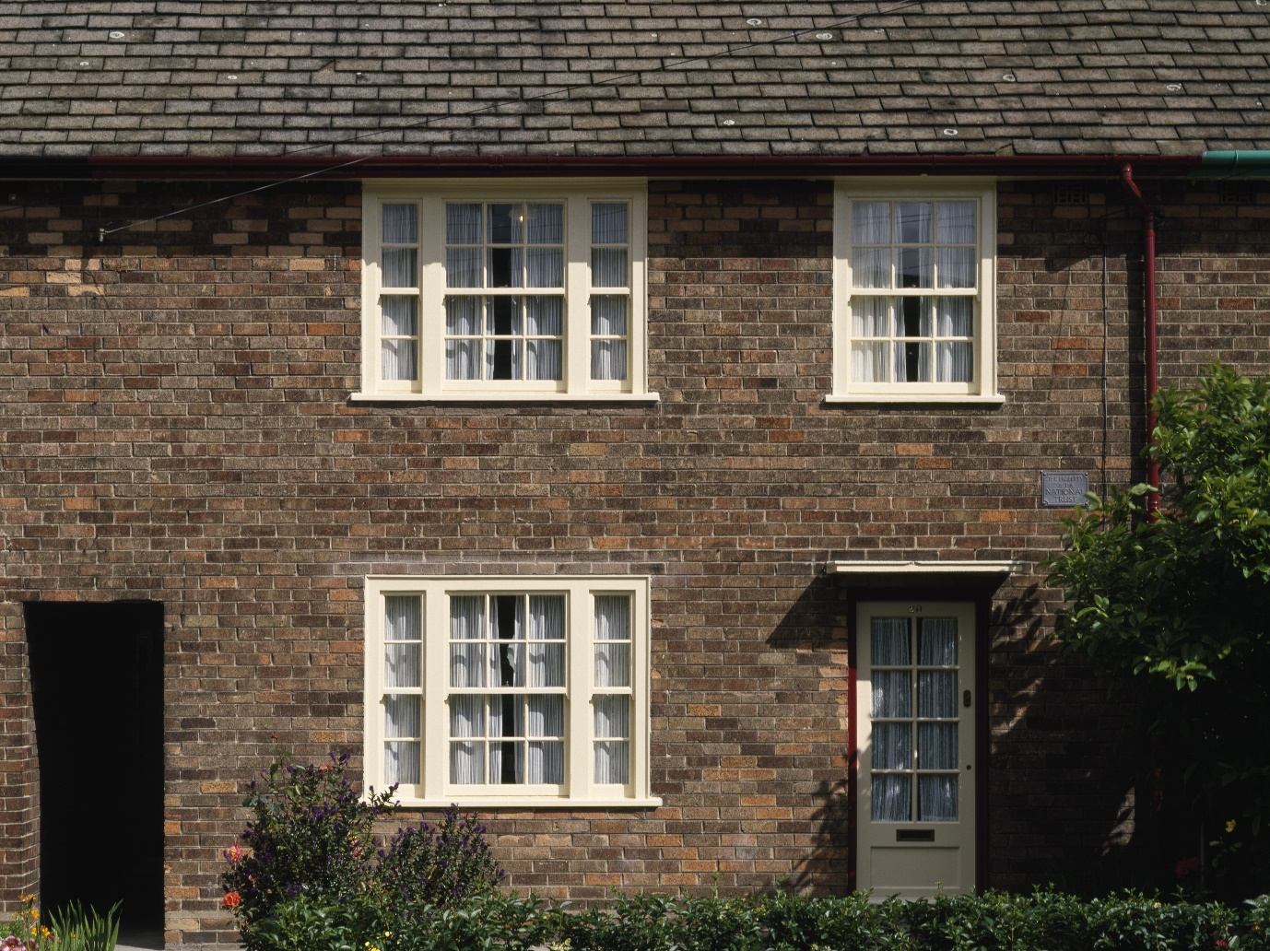
20 Forthlin Road. Photo courtesy of National Trust Images/Dennis Gilbert.

